Announcement and Call for Papers

The 27th International Symposium
on Logistics
(ISL 2023)

Managing Supply Chains during Geopolitical Turbulence

Enschede, Netherlands

9th – 12th July 2023

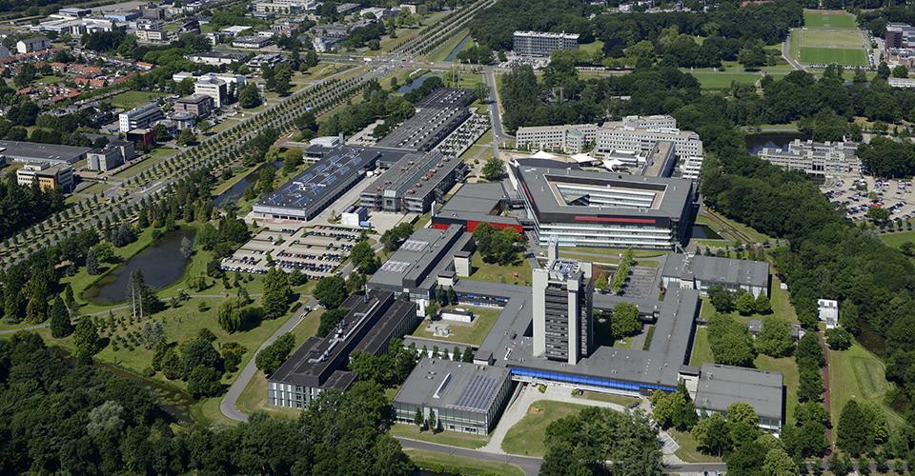

Organized by

www.ISL21.org

INTERNATIONAL ADVISORY COMMITTEE
Prof. M Abrahamsson, Linköping University, Sweden
Prof. R Accorsi, University of Bologna, Italy
Dr J Baalsrud Hauge, BIBA Germany, KTH Sweden
Prof. R Bai, University of Nottingham, Ningbo, China
Prof. R Banomyong, Thammasat University, Thailand
Prof. Emeritus D Bennett, Aston University, UK and Chalmers University of Technology, Sweden
Prof A Beresford, Cardiff University, UK
Prof. M Bourlakis, Cranfield University, UK
Prof C Chan, University of Newcastle, Australia
Prof. Y Chang, Korea Aerospace University, South Korea
Prof. P Childerhouse, Massey University, New Zealand
Prof. Emeritus M Christopher, Cranfield University, UK
Dr A Coronado, Royal Holloway U. of London, UK
Prof. S Dani, Keele University, UK
Dr Job de Haan, Tilburg University, The Netherlands
Prof. J Eschenbaecher, Bremen Germany
Prof. E Ferrari, University of Bologna, Italy
Prof. M Francis, Cardiff Metropolitan University, UK
Prof. B Gammelgaard, Copenhagen Business School, Denmark
Prof. C Glock, Technische Universität Darmstadt, Germany
Prof. M Goh, National University of Singapore, Singapore
Dr S Harding, Birmingham City University, Birmingham, UK
Dr J Havenga, University of Stellenbosch, South Africa
Dr F Huq, University of Manchester, UK
Prof. M Y Jaber, Ryerson University, Canada
Prof. B Kam, RMIT, Australia
Prof. Y Karasawa, Seijoh University, Japan
Prof. O Khan, Royal Holloway, University of London, UK
Dr P Lai, Chung Ang University, South Korea
Prof. Emeritus C Lalwani, Hull University, UK
Prof. T. Lirn, National Taiwan Ocean University, Taiwan
Mr P McCullen, University of Brighton, UK
Prof. T Masui, Musashi Inst. of Technology, Japan
Prof. Emeritus M Miyazaki, Tohoku University, Japan
Prof. M Muffatto, University of Padua, Italy
Prof. M Naim, Cardiff University, UK
Prof. M Ohba, Nihon University, Japan
Dr S O’Reilly, University College Cork, Ireland
Prof. R Pouraghabagher, CalPoly, USA
Prof. N Pujawan, Sepuluh Nopember Institute of Technology, Indonesia
Prof. S Rahman, RMIT University, Australia
Prof. J Schumacher, Fachhochschule Vorarlberg, Austria
Prof. J Shah, IIMU, Udaipur, India
Prof. N Subramanian, Sussex University, UK
Prof. M Sugawara, Iwate Prefectural University, Japan
Assoc. Prof. T Takeno, Iwate Prefectural University, Japan
Prof. K Tan, University of Nottingham, UK
Prof. C Tang, UCLA Anderson School, USA
Prof. K-D Thoben, BIBA, Germany
Dr N Tipi, The Open University, UK
Prof. K-m. Tsai, National Kaohsiung University of Science and Technology, Taiwan
Dr J Vilko, Lappeenranta University of Technology, Finland
Prof. S. Wagner, Swiss Federal Institute of Technology, Switzerland
Prof. K Wakabayshi, Nihon University, Japan
Prof. S Woo, Chung Ang University, South Korea
Prof. M Yu, Tsinghua University, China
Prof M Zhang, Queens University Belfast, UK
Prof. X Zhao, CEIBS, China

SYMPOSIUM ORGANISATION

Symposium Chair  Prof. Kulwant S Pawar  University of Nottingham, UK  Kul.Pawar@nottingham.ac.uk | Symposium Co-Chair  Dr Andrew Potter  Cardiff University, UK  PotterAT@cardiff.ac.uk
Symposium Co-Chair  Dr Christos Braziotis  University of Nottingham, UK  Christos.Braziotis@nottingham.ac.uk | Symposium Co-Chair  Prof. Helen Rogers  Nuremberg Institute of Technology, Germany  helen.rogers@th-nuernberg.de | Programme Co-Chair  Prof. Chandra S Lalwani  University of Hull, UK  c.s.Lalwani@hull.ac.uk
Paper Submission Management  Dr. Abhijeet Ghadge  Heriot Watt University, UK  A.Ghadge@hw.ac.uk | Symposium Administration

SCIENTIFIC PROGRAMME AND SYMPOSIUM AIMS
The fundamental goals of good logistics are to manage the movement of materials from the point of acquisition to the point of final consumption, as well as the associated information flows, with a view to providing excellent customer service at a reasonable cost. Achieving these goals requires fast and efficient management of internal and external resources within the context of global supply chain networks. Papers will represent the latest in academic thinking and case examples of successful implementations of ideas, models and concepts. The wider audience will therefore benefit from the knowledge and experience of leading practitioners and academics in this area.

The 27th International Symposium on Logistics aims to provide a forum for discussion between leading academics, researchers and practitioners who specialise in the area of logistics and supply chain management and to promote excellence in this field. The chosen theme for ISL2022 is “Managing Supply Chains during Geopolitical Turbulence”. We welcome papers original contributions on the developments in theory and practice in the area of logistics and supply chains. The 27th ISL aims to provide a forum for both academics and practitioners to discuss the current and future research in the area of logistics and supply chain management.

This major event for international scholars in the areas of Logistics, Operations and Supply Chain Management will hosted in Cork, following the successful in Cork 2022, online 2021, Würzburg 2019, Bali 2018, Ljubljana 2017, Kaohsiung 2016, Bologna 2015, Ho Chi Minh City 2014, Vienna 2013, Cape Town 2012, Berlin 2011, Kuala Lumpur 2010, Istanbul 2009, Bangkok 2008, Budapest 2007, Beijing 2006, Lisbon 2005, Bangalore 2004, Sevilla 2003, Melbourne 2002, Salzburg 2001, Iwate 2000, Florence 1999, Padua 1997 and Nottingham 1995 and 1993.

The official language of the Symposium is English.

SYMPOSIUM TOPICS
Contributed papers may deal with, but are not limited to the following:
- Building resilience for supply chains – considering how supply chains can respond to both short- and long-term risks and uncertainties, including responses to geo-political turbulance.
- Sustainability in logistics and supply chains – covering environmental/’green’ and social aspects, such as reverse logistics or employee welfare, as well as research that considers the ‘triple bottom line’.
- Smart/digital logistics and supply chains – covering all aspects of technology, including Industry 4.0, blockchain, e-Business, decision support systems and RFID.
- Supply chain analytics – covering the use of data for decision making, predictive models and supply chain planning as well as performance assessment of existing operations.
- Customer-supplier relationships – including dyads, triads and supply chain networks, and considering the nature and value of different collaborative relationships within product and service supply chains.
- Globalisation of supply chains – addressing management issues such as offshoring/near-shoring, outsourcing, trade regulations and associated cultural challenges.
- Humanitarian logistics – the requirements for logistics operations in addressing the aid needs of those affected by natural and man-made disasters.
- Logistics network design and management –logistics networks and their nodes, maritime logistics, distribution, multimodal transport and third-party logistics.
- Supply chain skills, training and education – addressing industry skills challenge in logistics and supply chain management including training needs and competencies, as well pedagogical and novel approaches to teaching.
- Electric mobility and charging infrastructure – including incentives, sources of power supply, battery life management and total cost of ownership.

INDICTATIVE DEADLINES
Indicative deadlines are:
- Working papers
  - Abstracts: 13th February 2023
  - Working papers (if provided): 29th May 2023
- Full papers
  - Abstracts and first drafts: 13th February 2023
  - Final versions of abstracts and full papers: 29th May 2023

