Designing cascades for systemic circularity in material/product circular supply chains (CASCADES)

Venue: Thammasat University

Sunday 7th July 2024 (15:15 – 18:00)

Workshop leaders:

Professor Rudrajeet Pal, Department of Business Administration & Textile Management, University of Borås, Sweden

Professor Erik Sandberg, Department of Management and Engineering, Linköping University, Sweden

Background
In recent years, circular economy (CE) has gained traction in many industrial supply chains due to its increasing potential to tackle sustainability concerns, and create job and economic growth (European Commission, 2020). Essential to CE is the functioning of circular supply chain (CSC) that that enable looping of materials and products upon which CE practices are conducted, thus orchestrating the inter-relationships and collaboration of diverse stakeholders (Parida et al., 2019). In this context, an emerging view of CE for enabling circular flow of material/product, either in same or different form, is cascading, i.e. connecting several CSCs across different resource loops (Campbell-Johnston et al. 2020).
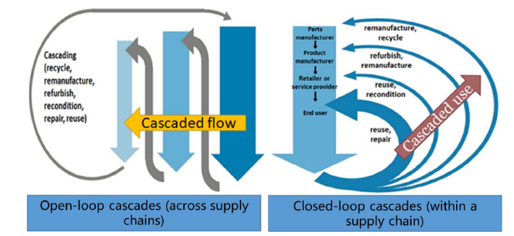
Closed-loops (depicted by “cascaded use” in the figure) can be typically envisaged to connect inner and outer resource loops of same material/product via product-service systems, sharing, reselling, remanufacturing and recycling, while open-loop flows (depicted by “cascaded flow” in the figure) support cascading of material/product in different forms, to organizations outside the original supply chain (Batista et al., 2018).
Cascading thus broadly encompasses systemic arrangement of several CSCs with the aim to increase the efficiency of resource utilization, and the most common practices are typically: by optimizing the flow of material from highest to lowest value form, by optimizing co-production (of product and by-products), and through sequential use of resources (Odegard et al., 2012), as noticed in different industrial supply chains. For example, in the manufacturing sector, for bio-based materials, such as wood, agriculture and food (Rehberger & Hiete, 2020, Jarre et al., 2020), cascading of wastes and by-products are primarily applied in biorefineries, which involve both conventional waste-to-energy strategies and new pathways for material use, such as bioplastics. On the other hand, in technical nutrient value chains, material/product lifetime is optimized by integrating several strategies, such as repair, reuse, remanufacture, refurbish by maintaining the material/product integrity in the highest value forms. Overall, cascading aims at retaining and recharging end-of-use or end-of-life products with new value and is analogous to “a river flowing over a sequence of plateaus” (Sirkin & ten Houten, 1994) essential for gaining resource effectiveness and optimizing product value retention over extended lifetime (De Angelis et al., 2018), thus vital for improving climate gains.
From a logistics and supply chain management perspective, this calls for critical systems thinking for designing and configuring novel value chains, both intra- and inter- organizationally and industrially, identifying ecosystem collaboration and orchestration capabilities, and exploring the governance mechanisms, along with the antecedents and barriers to it. However, such systemic perspective of supply chains in CE context has been largely ignored, and in practice hindered by the complexities of operationalizing CSCs in system for delivering transformational value proposition, i.e. long-lasting products, and rethinking of business stakeholder’s role for building new collaborative relationships (Batista et al., 2018, Pal et al., 2019).

Purpose of the workshop
This year’s workshop will discuss how circular material/product flows are operationalized, and stakeholders are engaged, across circular supply chains in designing and implementing cascading in a resource-effective way. Participants will pool their diverse backgrounds and expertise to brainstorm, poll and discuss on:
- Identifying current external enablers and barriers to appropriate cascading,
- Identifying current internal (supply chain level) strategies and operations enablers and barriers to implement cascading material/product flows, and
- Elaborating on some of the future needs and directions in supply chain management to implement cascading.

Outline of the Workshop
The workshop will follow the approximate timetable below:
15:15 - 15:30 Tea/coffee & Networking
15:30 - 15:50 Welcome and brief introduction to the workshop topic by Rudrajeet Pal and Erik Sandberg
15:50 - 16:05 Cascading in different industrial settings - 3 perspective talks
16:05 - 16:15 Workshop process and key questions by Rudrajeet Pal and Erik Sandberg
16:15 - 18:00 Workshop, discussion and concluding summary.

References
Batista, L., et al., 2018, In search of a circular supply chain archetype – a content-analysis-based literature review, Prod. Plan. Cont., 29(6), 438-451
Campbell-Johnston, K. et al., 2020, The Circular Economy and Cascading: Towards a Framework. Res. Conserv. Recycl., X 7, 100038
De Angelis, R. et al., 2018, Supply chain management and the CE: towards the circular supply chain, Prod. Plan. Cont., 29(6), 425-437
European Commission (2020), A new Circular Economy Action Plan For a cleaner and more competitive Europe. https://eur-lex.europa.eu/legal-content/EN/TXT/?uri=COM:2020:98:FIN
Jarre et al., 2020, Transforming the bio-based sector towards a circular economy - What can we learn from wood cascading, Forest. Pol. Econ., 101872
Odegard, I. et al., 2012. Cascading of Biomass, 13 Solutions for a Sustainable Bio-based Economy, Making Better Choices for Use of Biomass Residues, By-products and Wastes. CE Delft, Delft, The Netherlands.
Pal, R. et al., 2019, Circular fashion supply chain management: Exploring impediments and prescribing future research agenda, J. Fash. Market. Manag., 23(3), 298-307
Parida, V et al., 2019, Orchestrating industrial ecosystem in circular economy: A two-stage transformation model for large manufacturing companies, J. Bus. Res., 101, 715-225
Rehberger, M & Hiete, M., 2020, Allocation of environmental impacts in circular and cascade use of resources, Sustain., 12, 4366
Sirkin, T., & ten Houten, M., 1994, The Cascade Chain A Theory and Tool for Achieving Resource Sustainability with Applications for Product Design, Res. Conserv. Recycl., 10, 213-277

